What I wanted to discuss was the onboarding when you first open the app needs to be redesigned I built what it should look like.
Now all the information is on there step by step
I need the shop reworked I built what it should look like with all the information I just want added in another google doc. In this part I would prefer you call me because it’s a little complicated.
The reason we have it like this is because my app runs the risk of being kicked of the App Store and I need to make sure it doesn’t

(0) We are reworking the beaker screen

Now i want some animation like bubbling animation in the water Liquid glow pulse
micro bounce

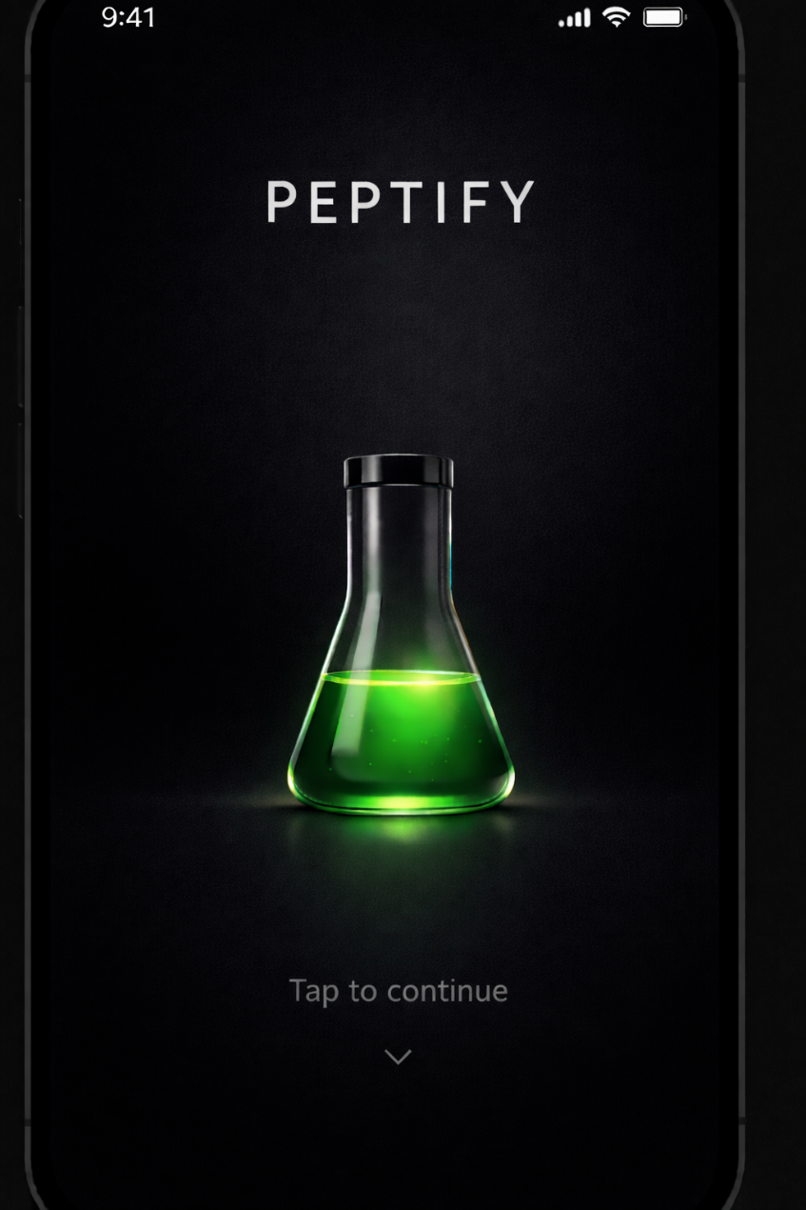

- First thing shown before beaker screen

Title

Adults Only (21+)

Body

This app contains educational content intended for adults only.
By continuing, you confirm that you are 21 years of age or older.

Buttons

I am 21+

Exit

Full-screen modal (what it should look like)

Appears before ANY content loads

Blocks:

home screen

compound pages

research list

outbound links

User must make an explicit choice

Store a single boolean flag (no DOB, no PII)

Logic

If user has not accepted → show gate

If user declines → block app usage

(2) Medical Disclaimer (SECOND, NON-BLOCKING ACKNOWLEDGMENT)

After age acceptance, show one lightweight acknowledgment screen.

This can:

fade in after the age gate

or appear as a modal over a neutral background

or appear during the logo/splash moment

This screen should require one tap, but it should not feel heavy or scary.

Exact medical disclaimer copy (DO NOT EDIT)

Title:
Educational Use Only

Body:
This app provides educational and informational content only.
It does not provide medical advice and is not intended to diagnose, treat, cure, or prevent any disease.
Always consult a licensed healthcare professional regarding medical decisions.

Button:

Continue

()
Add a third screen after the Medical Disclaimer

This screen is Terms & Privacy acknowledgment.

It should look like this:

Title:
Terms & Privacy

Body:
By continuing, you agree to our Terms & Conditions and Privacy Policy.

Links (inline):

Terms & Conditions

Privacy Policy

Button:
Continue

That’s it.

No checkbox required (Apple does not require checkboxes).
A single “Continue” is fine.

So this is the link we will have for terms and conditions and what should pop up after tapped

Terms & Conditions
1. Acceptance of Terms

By accessing or using this application, you agree to be bound by these Terms & Conditions. If you do not agree, do not use the app.

2. Eligibility

You must be at least 21 years of age to access or use this app.

3. Purpose of the App

This app is provided solely for educational and informational research reference purposes.
The app is not intended to provide professional, medical, or clinical guidance.

4. No Medical Advice

The app does not provide medical advice, diagnosis, treatment, or healthcare services.
Information presented should not be relied upon for medical decisions.

5. No Commerce Within the App

The app does not sell, distribute, or process purchases of any products or substances.
Any references to compounds are provided strictly in a research and informational context.

6. Research Context Only

Compounds discussed in the app are referenced for research and academic purposes only.
Human applications, dosages, administration methods, or outcomes are not established or provided within the app.

7. Third-Party Websites

The app may include links to third-party websites for general research reference.
These websites are not owned, operated, or controlled by the app, and the app is not responsible for their content, products, or services.

8. User Responsibility

You are responsible for how you interpret and use information accessed through the app.
The app is not responsible for actions taken based on information viewed within or outside the app.

9. Disclaimer of Warranties

The app is provided “as is” and “as available” without warranties of any kind, express or implied.

10. Limitation of Liability

To the maximum extent permitted by law, the app shall not be liable for any damages arising from use of the app or reliance on its content.

11. Changes to These Terms

These Terms may be updated from time to time. Continued use of the app constitutes acceptance of any changes.

12. Contact

For questions regarding these Terms, contact:
[support@yourdomain.com

This is the terms and conditions we will have for now

Now this is what should happen after tapped into privacy

Privacy Policy
1. Overview

This Privacy Policy explains how this app collects, uses, and protects information when you use the app.

2. Information We Collect

We collect only the information necessary to operate the app and provide its features.

This may include:

Account information (such as email address)

App usage data related to saved research and preferences

Device and technical information (such as app version and device type)

We do not collect sensitive personal data.

3. How Information Is Used

Information collected is used solely to:

Provide and maintain app functionality

Save user preferences and research lists

Improve app performance and reliability

Communicate with users regarding app-related matters

4. Data Sharing

We do not sell, rent, or trade personal information.

Information may be shared only:

With service providers necessary to operate the app

When required by law

5. External Websites

The app may include links to third-party websites for general research reference.
We are not responsible for the privacy practices or content of third-party websites.

6. Data Security

We take reasonable measures to protect user information from unauthorized access, disclosure, or misuse.

7. User Rights

Users may request access to, correction of, or deletion of their account information by contacting support.

8. Children’s Privacy

This app is intended for users 21 years of age or older.
We do not knowingly collect information from individuals under 21.

9. Changes to This Policy

This Privacy Policy may be updated from time to time. Continued use of the app indicates acceptance of the updated policy.

10. Contact

